List of questions for creating test plan for CiviHR Recruitment Kanban screen

Access and View

- How to access Kanban Recruitment dashboard for a vacancy? Assume it is from Vacancies menu > Find Vacancies

- Having that Admin users have the right to view, add, edit, reject candidates in Kanban screen, what rights will have managers and staff members? Will they be allowed to view it only from Self Service Portal and apply filters for vacancies and candidates?

- According to CiviHR demo, Vacancy statuses can be Draft, Open, Closed, Cancelled, Rejected. Please clarify which vacancies will be eligible for displaying in Kanban.

- Will be possible to view existing Applicants in Kanban screen? Currently a vacancy allows stages like Apply, Ongoing, Phone Interview, Manager Interview, Board Interview, Group Interview, Psych Exam, Offer, Hired. Assume these stages will be loaded and displayed in Kanban.

- Will Kanban board have vertical scrollbars in case user needs to scroll down/up to view all candidates? From wireframe screenshot it has horizontal scrollbars.

Action

- Will the user be prevented from moving a candidate 2 stages forward, for ex. from [Applied] stage to [Director Interview]? If yes, what is the expected error message.

- Is it mandatory to enter transition comment when updating candidate stage?

- What happens after pressing Submit button on Comment tab from Update candidate? Will the candidate be placed into new stage, or the next tab Email be displayed for further action? The same question when pressing Submit from Email tab.

- Is it expected [From] field in Email sub-menu to be generated with the name of the user logged in. Will it be implemented?

- What fields are required when creating email template? Assume it’s Template name and body message

- Will Quick task display pre-loaded tasks, similar to tasks displyed in creating Assignment?

- From wireframe screenshot all pre-loaded tasks are selected. Is this the intention?

- What are the fields for creating a quick task template?

- Is rejection comment a mandatory field?

- Is it mandatory to send email when rejecting a candidate? What fields are required for sending the email?

- Will the drop-down menu for selecting the email template be displayed on Reject window?

- How vacancies will be displayed when choosing to filter by My Vacancies, All Vacancies, Due Today, Past Due? Please clarify if they will be in a grid similar to the one from Find Vacancies

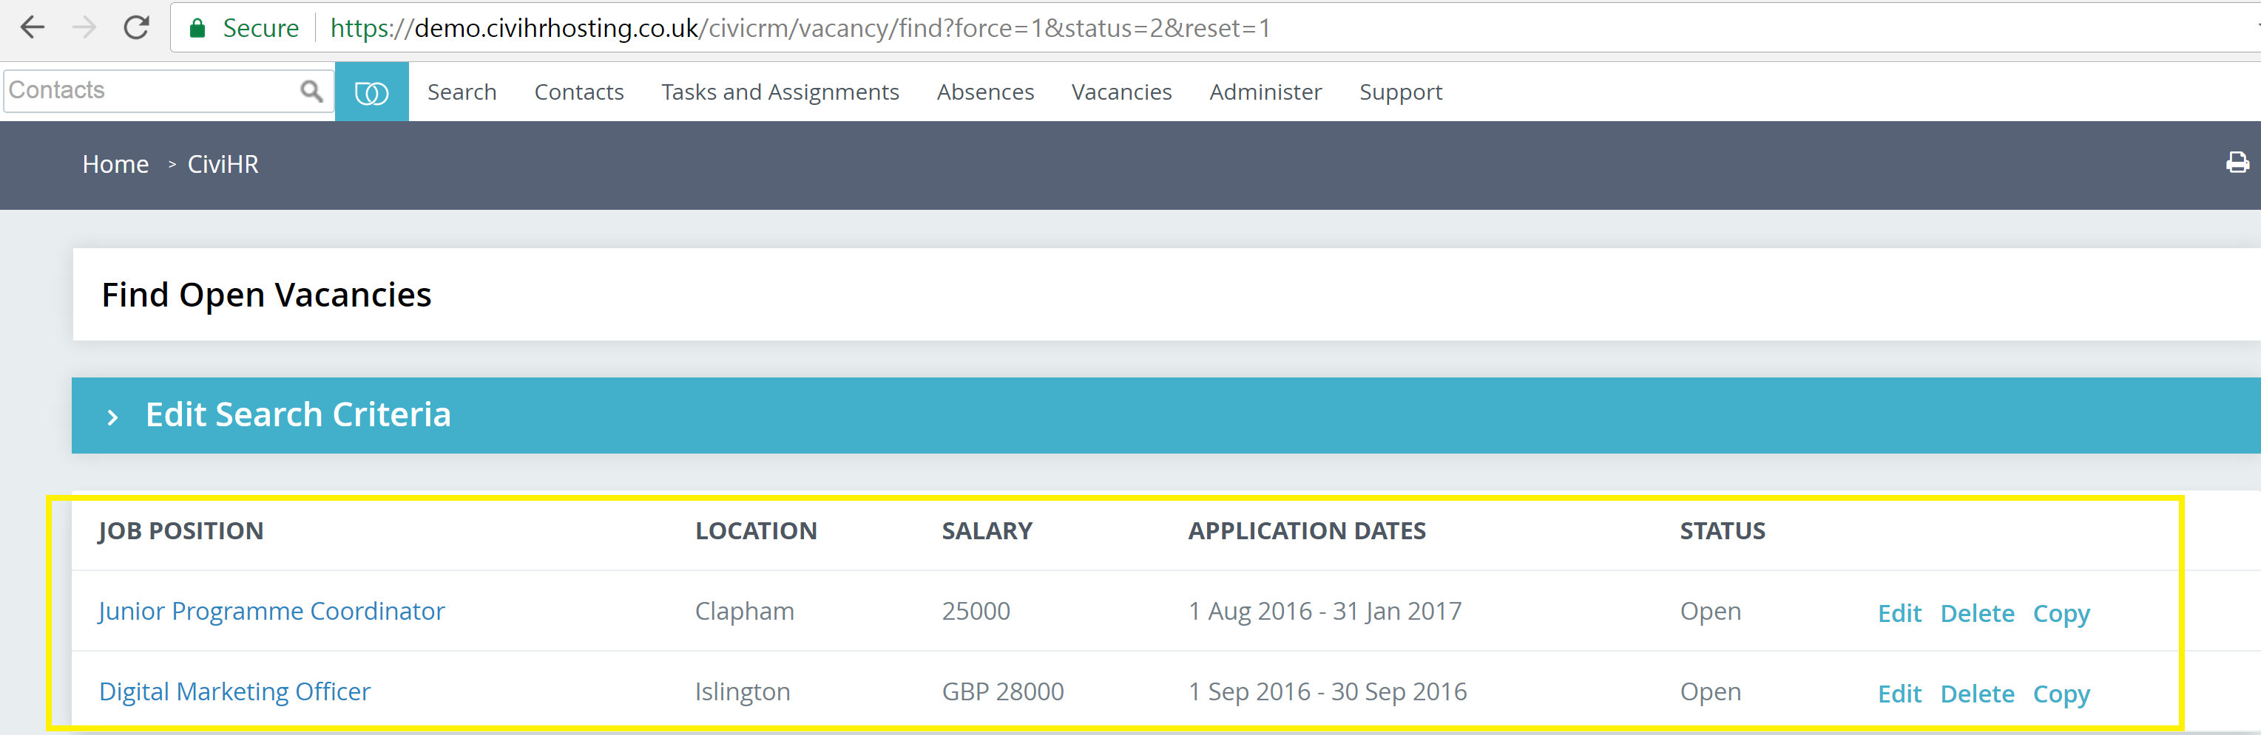
- How will be displayed the results of filtering candidates from More Filters? Please clarify if they will be in a grid and what columns will available

- What would be the results of checking Referred candidates only in Filters?
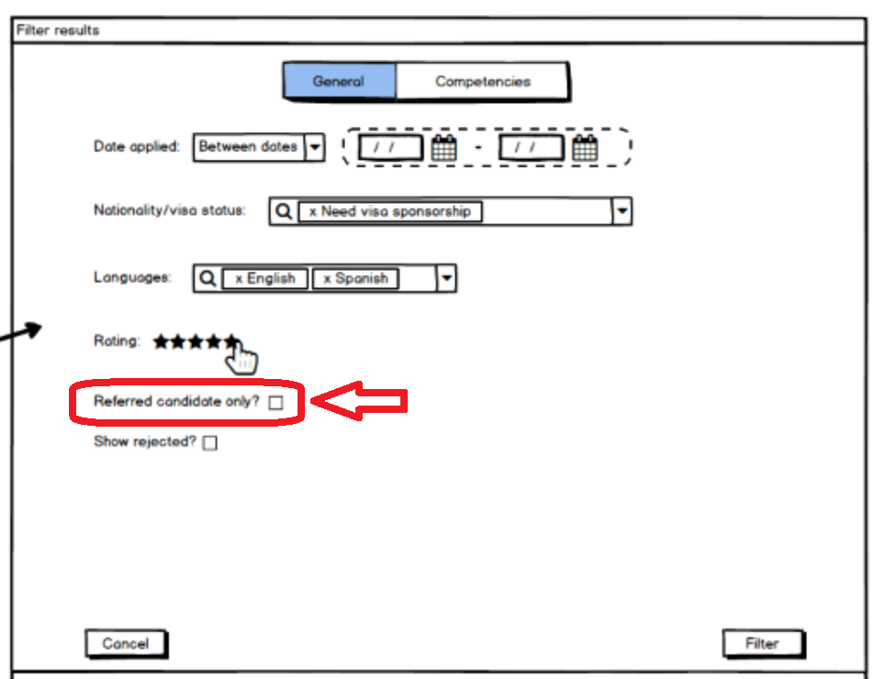

- Could you please specify the purpose of Select Competencies drop down? In case user selects another option, will the tab next to General be changed as well?

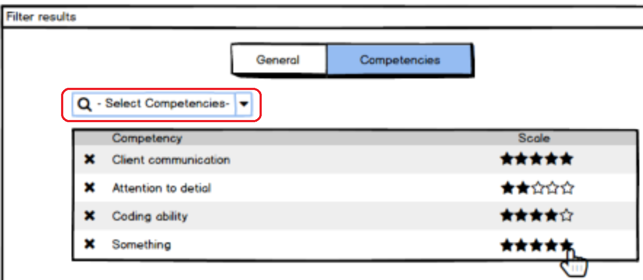

- Kindly confirm if checking the Acrobat icon from candidate card will display Application form? Will it be View only?

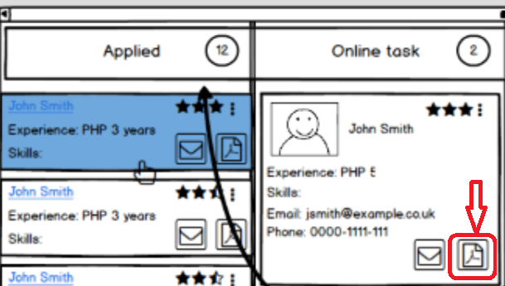

- Will user be able to send email to candidate when clicking on Email icon from candidate card? What fields will be displayed?

- What options will be available in More Options menu from candidate card, as marked with red in screenshot below?

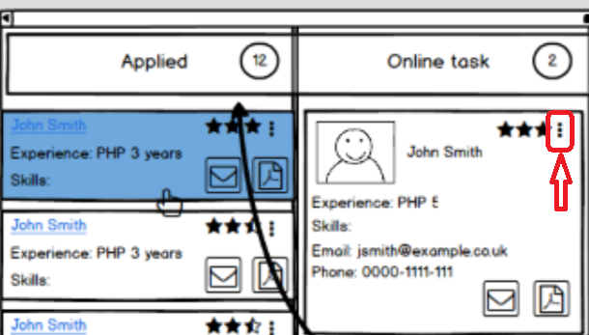

- Is it possible to edit candidate data from Kanban board? If yes, please provide more details on what fields are editable.

- Is it possible to delete candidate from Kanban board? If yes, please clarify if candidate is going to be deleted from Kanban board only.

- Is the newly added Applicant placed into Applied stage on Kanban board?

- What happens to candidate cards if the Vacancy is closed or rejected?

- Is it possible to bulk reject candidates, or this is done by changing Vacancy status to Rejected?

Configuration

- Will the new Kanban Recruitment board be configurable for admins? For example, will it be possible for Admin to add a new dashboard stage from configuration?

